DESIGN 1 WEB DESIGN FUNDAMENTALS TERM 1
How to Really Build a Website
Your Study Guide

Everything you need to know about HTML, made easy to actually read.

How to Use This Guide
This guide isn't organized week by week. It's organized by topic, so you can jump to any concept from the whole unit and it'll still make sense. Every chapter follows the same pattern:
Big Idea The one sentence that matters most.
Key Terms The vocabulary you need, in plain language.
Try It A real code snippet you can copy the pattern from.
Did You Know? A real world connection to make it stick.
Try This A quick activity to practice the idea yourself.
Quick Check Questions to test if it really sunk in.

 MEET ZAYD
Throughout this guide we'll follow one running example: a student named Zayd building his first real website, from a blank file to a finished, multi-page site. He's a made up example, but every step is exactly the process you're using in your own project.

What's Inside
 Chapter 1 What Is a Webpage Made Of?
 Chapter 2 Structuring & Formatting Text
 Chapter 3 Linking Pages Together
 Chapter 4 Adding Images
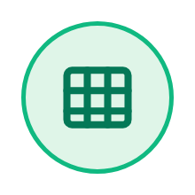 Chapter 5 Displaying Data with Tables
 Chapter 6 Collecting Information with Forms
 Chapter 7 Building a Complete, Multi-Page Website
 Chapter 8 Planning, Testing & Presenting Your Project
Plus: the Design Cycle recap, the full glossary, a project readiness check, and a closing note.

 | CHAPTER 1  What Is a Webpage Made Of?

Every webpage is built from HTML: a set of tags that tell the browser what each piece of content is, wrapped inside a required document structure.
Meet Zayd. This term he built a real website from nothing, starting with a single blank file. Before he wrote anything visible, he learned that every HTML page needs the exact same skeleton: a doctype, an html tag, a head, and a body. We'll follow his site through every chapter of this guide.
HTML doesn't make things look pretty on its own. It structures content using tags, so the browser knows this is a heading, this is a paragraph, this is a link. A tag is a keyword in angle brackets, like <p> or <h1>. An element is a complete unit: an opening tag, its content, and a closing tag together.
TRY IT
<!DOCTYPE html>
<html>
<head>
<title>Page Title</title>
</head>
<body>
<!-- Everything visible goes here -->
</body>
</html>

KEY TERMS
HTML The code language used to structure content on a webpage. The skeleton every browser reads to build what you see.
Browser The program (Chrome, Safari, Edge) that reads HTML files and displays them as a webpage.
Tag A keyword in angle brackets, like <p> or <h1>, that tells the browser what a piece of content is.
Element A complete piece of HTML: an opening tag, its content, and its closing tag together.
Attribute Extra information inside an opening tag that gives more detail, like the href in a link.
Website A collection of connected webpages, reachable from one starting address.
Webpage A single page of content on the web, written in HTML.
Syntax The exact rules for writing code correctly, like grammar rules for HTML.
Doctype Declaration The first line of an HTML file, telling the browser which version of HTML to expect.
Head The part of a document that holds page info like the title. Nothing inside it shows on the page.
Body The part of a document that holds everything visible to a visitor.
Nesting Placing one HTML element inside another, so the inner one is fully contained.
Opening Tag The first half of an element, written as <tagname>.
Closing Tag The second half of an element, written as </tagname>.
Case Sensitivity Tags and attributes should stay consistently lowercase to avoid errors.

 DID YOU KNOW?
The first ever webpage, created in 1991, is still online today. It was written by Tim Berners-Lee and used almost none of the styling we take for granted now, just headings, paragraphs, and links.

 TRY THIS
Open any website, right click, and choose View Page Source. See if you can spot the doctype, the head, and the body in someone else's real HTML.

QUICK CHECK
☐ What are the four parts every HTML file needs, in order?
☐ What is the difference between a tag and an element?

 | CHAPTER 2  Structuring & Formatting Text

Headings create a hierarchy that organizes a page, and specific tags let you format and list text with real meaning, not just visual style.
With his skeleton ready, Zayd started on his homepage. He used one h1 for his main heading and h2s for each new section, careful never to skip a level just because a smaller heading looked better in the moment.
For his hobbies list, he had a choice to make. An unordered list made more sense than a numbered one, because the order his hobbies were listed in didn't actually matter.
TRY IT
<h1>My Website</h1>
<p>Welcome to my personal site.</p>

<ul>
<li>Reading</li>
<li>Coding</li>
<li>Football</li>
</ul>

KEY TERMS
Heading A heading tag (h1 through h6) that labels a page or section. h1 is most important, h6 least.
Paragraph The <p> tag, used to group related sentences into one block of text.
Hierarchy An ordered structure from most to least important, like heading levels.
Strong The <strong> tag marks text as important, usually shown in bold.
Emphasis The <em> tag marks text as emphasized, usually shown in italics.
Semantic HTML chosen for its meaning, not just how it happens to look.
Ordered List A numbered list (<ol>), used when the sequence of items matters.
Unordered List A bulleted list (<ul>), used when the order of items doesn't matter.
List Item The <li> tag. Each individual entry inside a list.
Nested List A list placed inside a list item of another list, to show sub-groups.

 DID YOU KNOW?
Screen readers announce <strong> and <em> differently than plain bold or italic text. Choosing the semantic tag, not just a bold looking style, actually changes what a blind visitor hears.

 TRY THIS
Write a short About Me section for yourself with one h1, two h2s, and one unordered list of three things you enjoy.

QUICK CHECK
☐ When should you use an ordered list instead of an unordered list?
☐ Why can skipping a heading level cause a real problem, not just a style one?

 | CHAPTER 3  Linking Pages Together

Hyperlinks are what turn a set of separate HTML files into a connected website, and consistent navigation is what makes that website usable.
Zayd now had three separate files: home, about, and contact. On their own they were just files sitting in a folder. The anchor tag was what actually turned them into a website, by letting a visitor click from one page to the next.
He built one navigation menu and pasted it into every page in exactly the same place, so a visitor could always find their way back to Home, no matter which page they landed on.
TRY IT
<nav>
<ul>
<li><a href="index.html">Home</a></li>
<li><a href="about.html">About</a></li>
<li><a href="contact.html">Contact</a></li>
</ul>
</nav>

KEY TERMS
Hyperlink Clickable text or an image that takes the user somewhere else when clicked.
Anchor Tag The <a> tag, the HTML element used to create a hyperlink.
href The attribute inside an anchor tag that holds the destination address.
Absolute Link A link using a full web address, usually pointing to another website.
Relative Link A link using just a filename or short path, for a page in the same project.
Navigation The system of links, often a menu, that lets a visitor move between pages.

 DID YOU KNOW?
A broken link is sometimes called a 404, after the browser status code used when a page can't be found. It's one of the most common bugs on real websites, usually caused by a single typo in a filename.

 TRY THIS
List the pages your own website (real or imagined) would need, then draw arrows connecting which pages should link to which.

QUICK CHECK
☐ What's the difference between an absolute link and a relative link?
☐ Why should the same navigation menu appear on every page of a site?

 | CHAPTER 4  Adding Images

Images are embedded with a self-closing tag that needs both a location and a text description to work properly for every visitor.
Zayd wanted a photo on his About page. The img tag surprised him. It had no closing tag at all, just src pointing to the file and alt describing what was in it.
He almost skipped the alt text, since nobody would notice it was missing. Then he learned it's what a screen reader actually reads aloud, and what shows up if the image ever fails to load.
TRY IT
<img src="images/profile.jpg" alt="A photo of me smiling outdoors" width="300">

KEY TERMS
Image Tag (img) The self-closing <img> tag used to embed a picture in a webpage.
Source (src) The attribute that tells the browser where to find the image file.
Alt Text A description of an image, used by screen readers and shown if the image fails to load.
File Path The route the browser follows to find a file, like the folder plus the filename.

 DID YOU KNOW?
Alt text isn't just for accessibility. Search engines can't see images either. They read the alt text to understand what a picture shows, which is part of how a page gets found in search results.

 TRY THIS
Find a photo on your device and write a one sentence alt text description for it, as if you couldn't see the image at all.

QUICK CHECK
☐ What two attributes does an img tag need to work properly?
☐ Name two different reasons alt text matters, beyond just being polite.

 | CHAPTER 5  Displaying Data with Tables

Tables organize information into rows and columns, and only for real tabular data, never for positioning content on a page.
Zayd wanted to show his weekly football training schedule. A table was exactly the right tool this time: real rows and real columns of actual data, not just a way to line things up on the page.
He built it one row at a time: a header row with th cells for the day names, then a regular tr with td cells underneath for each session.
TRY IT
<table>
<tr>
<th>Day</th>
<th>Subject</th>
</tr>
<tr>
<td>Monday</td>
<td>Design</td>
</tr>
</table>

KEY TERMS
Table The <table> tag, used to organize data into rows and columns, not for page layout.
Table Row The <tr> tag. One horizontal row of a table.
Table Data / Cell The <td> tag. One individual cell of data inside a row.
Table Header The <th> tag, used for column or row titles, shown bold by default.
Colspan An attribute that makes a cell stretch across multiple columns.

 DID YOU KNOW?
Long before CSS existed, web designers used tables to lay out entire pages, sidebars, menus, and all. It worked, but it made pages slow and hard to update, which is exactly why tables are reserved for real data now.

 TRY THIS
Sketch a 3 row, 2 column table on paper for any real data you have (a schedule, scores, prices), then label which cells would be th and which would be td.

QUICK CHECK
☐ Why shouldn't a table be used just to position content on a page?
☐ What does the colspan attribute do?

 | CHAPTER 6  Collecting Information with Forms

Forms are what make a website interactive, grouping input fields together so a site can actually collect information from a visitor.
For his contact page, Zayd needed something new: a way for visitors to actually send him a message, not just read his page. That meant a form.
He built a label for every input and made sure each label's for attribute exactly matched its input's id. The first time he tested it, one label wouldn't click through to its field, and a single mismatched id turned out to be the whole problem.
TRY IT
<form>
<label for="name">Your Name:</label>
<input type="text" id="name" name="name">
<button type="submit">Submit</button>
</form>

KEY TERMS
Form The <form> tag, a container that groups input fields together.
Input The <input> tag, a field where a user types or selects data.
Label The <label> tag, text that names an input and is linked to it.
Button The <button> tag, a clickable element often used to submit a form.
Input Type The type attribute on an input, controlling what kind of data it collects.
Textarea The <textarea> tag, an input box for longer, multi-line text.
Radio Button An input type that lets a user pick exactly one option from a group.
Checkbox An input type that lets a user select any number of options.
Dropdown (Select) The <select> tag, a menu that shows options only when opened.

 DID YOU KNOW?
The type attribute on an input does more than you'd think. Setting it to email makes phones show an @ key on the keyboard automatically, and lets the browser check the format before the form is even submitted.

 TRY THIS
Sketch a simple contact form on paper. Which fields would you actually need, and which input type fits each one?

QUICK CHECK
☐ What has to match exactly for a label to correctly focus its input?
☐ When would you use a checkbox instead of a radio button?

 | CHAPTER 7  Building a Complete, Multi-Page Website

A real website combines everything you've learned into multiple connected pages with consistent design, planned before it's built.
Before touching his final draft, Zayd sketched a site map on paper: every page his site would have, and how they would connect. It took ten minutes and saved him from restructuring everything halfway through.
His site didn't come together perfectly the first time, and that was expected. He built a version, tested it, found problems, and improved it. That's iterative design, not a failure, just how real websites get built.
KEY TERMS
Wireframe A simple sketch showing where content will go on a page, made before writing code.
Iterative Design Building, testing, and improving something in repeated rounds.
Design Specification A written plan naming who a product is for and how you'll know it succeeded.
Target Audience The specific group of people a website is designed for.
Site Map A list or diagram of every page a website will have and how they connect.

 DID YOU KNOW?
Professional web design teams often spend more time on wireframes and site maps than on the actual code. Planning on paper is far faster to change than a half built website.

 TRY THIS
Pick a hobby or interest of yours and sketch a 4 page site map for a website about it. What would each page be, and which pages would link to which?

QUICK CHECK
☐ What's the difference between a wireframe and a site map?
☐ Why is “everyone” not a real target audience?

 | CHAPTER 8  Planning, Testing & Presenting Your Project

A website isn't finished when it's built. Testing with real users, refining based on feedback, and explaining your decisions are all part of the process.
Before submitting, Zayd asked a classmate to actually use his site, not just look at it. Watching someone else click through it, he found a heading that skipped a level and a link pointing to the wrong file, both invisible to him after staring at his own code for weeks.
When something broke, he didn't panic. He checked the browser console, checked that every tag closed, checked the most recent change he'd made, and found the bug in under a minute.
KEY TERMS
Usability How easy and pleasant a website is to actually use for the people it's designed for.
Testing Deliberately checking a product against real use cases to find problems before others do.
Debugging The process of finding and fixing errors in code.
Bug An error in code that causes something to not work correctly.

 DID YOU KNOW?
Professional developers call this same debugging habit rubber duck debugging: explaining your code line by line to an object on your desk (traditionally a rubber duck) often reveals the bug before you finish the sentence.

 TRY THIS
Ask someone else to use something you made (a website, a game, anything) while you watch silently. Don't help them. Just notice where they get stuck.

QUICK CHECK
☐ What's the difference between usability and just “looking nice”?
☐ What's the first thing you should check when your own most recent change breaks something?

The Design Cycle, All Together
Every chapter in this guide connects back to this same cycle.
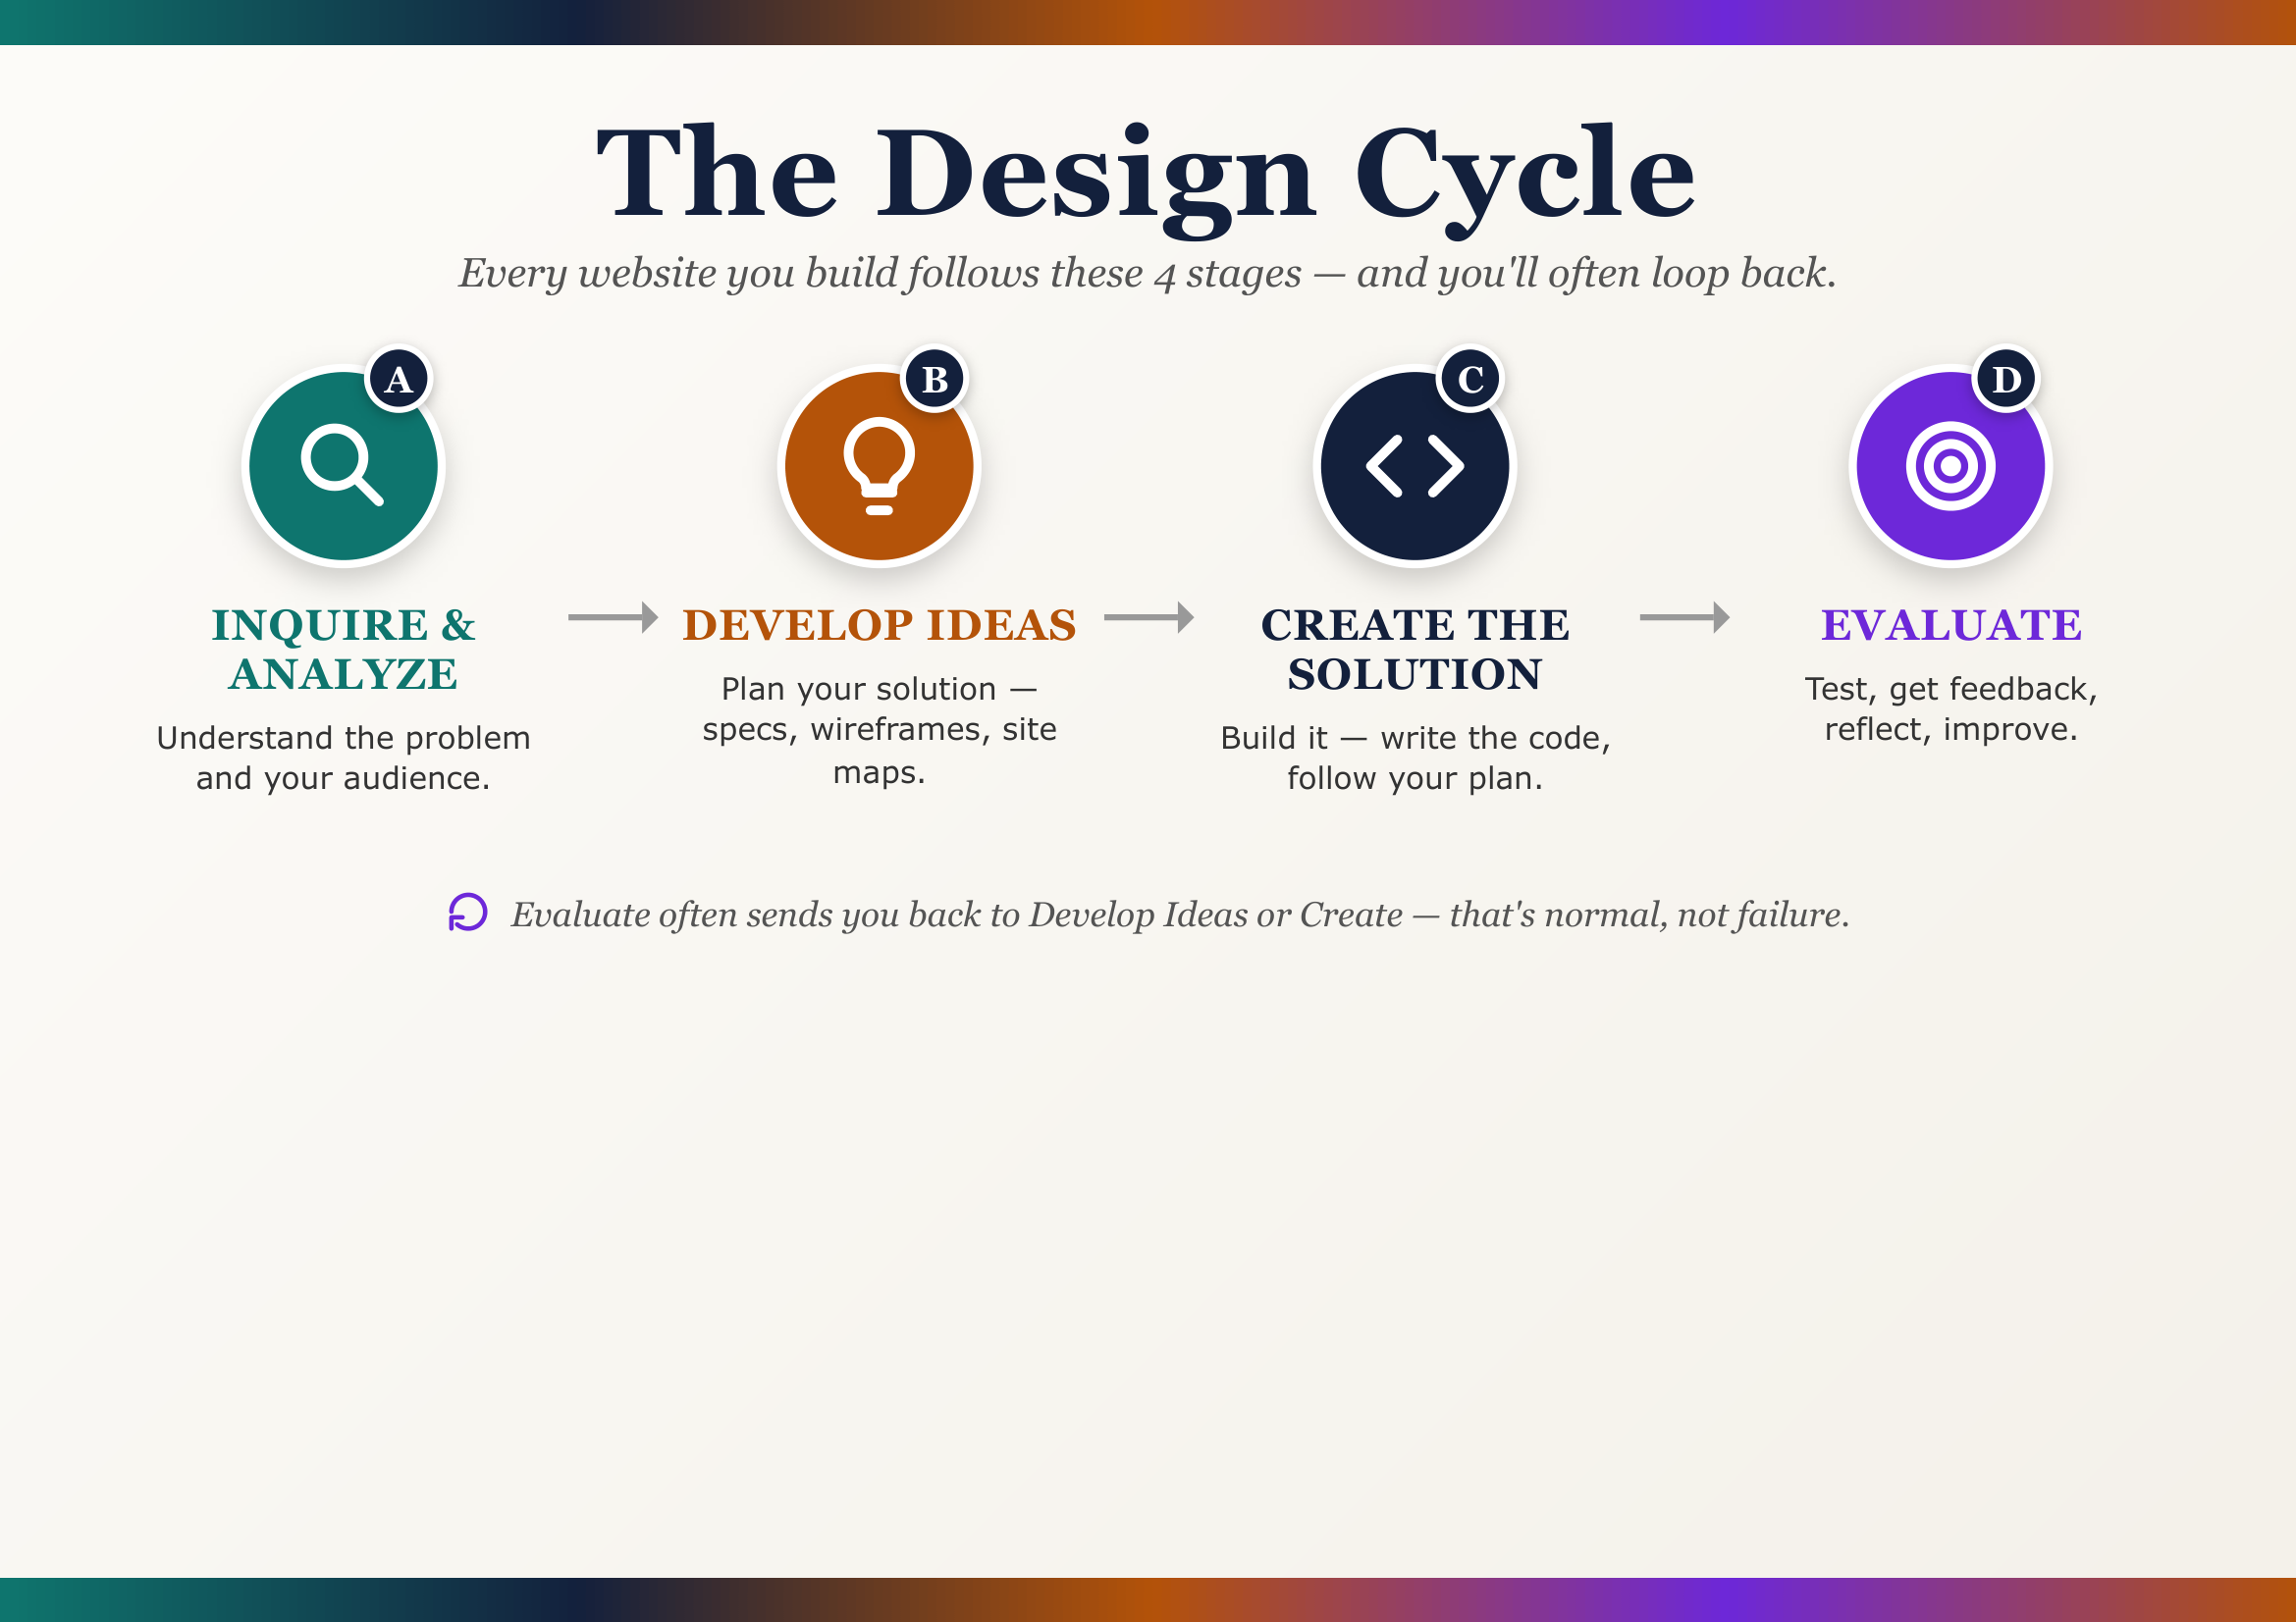

 REMEMBER
Evaluate often sends you back to Develop Ideas or Create. That's not a mistake, that's the process working, and it's exactly what Zayd's testing chapter was really about.

Full Glossary
All 60 terms from the unit, A to Z.
Absolute Link A link using a full web address, usually pointing to another website.
Alt Text A description of an image, used by screen readers and shown if the image fails to load.
Anchor Tag The <a> tag, the HTML element used to create a hyperlink.
Attribute Extra information inside an opening tag that gives more detail about an element.
Body The part of a document that holds everything visible to a visitor.
Browser The program that reads HTML files and displays them as a webpage.
Bug An error in code that causes something to not work correctly.
Button The <button> tag, a clickable element often used to submit a form.
Case Sensitivity Tags and attributes should stay consistently lowercase to avoid errors.
Checkbox An input type that lets a user select any number of options.
Closing Tag The second half of an element, written as </tagname>.
Code Editor A program used to write and save code, without adding hidden formatting.
Colspan An attribute that makes a cell stretch across multiple columns.
Debugging The process of finding and fixing errors in code.
Design Specification A written plan naming who a product is for and how you'll know it succeeded.
Doctype Declaration The first line of an HTML file, telling the browser which version to expect.
Dropdown (Select) The <select> tag, a menu that shows options only when opened.
Element A complete piece of HTML: an opening tag, its content, and its closing tag together.
Emphasis The <em> tag marks text as emphasized, usually shown in italics.
File Extension The letters after the dot in a filename, telling the computer what kind of file it is.
File Path The route the browser follows to find a file.
Form The <form> tag, a container that groups input fields together.
Head The part of a document that holds page info like the title.
Heading A heading tag (h1 through h6) that labels a page or section.
Hierarchy An ordered structure from most to least important.
href The attribute inside an anchor tag that holds the destination address.
HTML The code language used to structure content on a webpage.
Hyperlink Clickable text or an image that takes the user somewhere else.
Image Tag (img) The self-closing <img> tag used to embed a picture in a webpage.
Input The <input> tag, a field where a user types or selects data.
Input Type The type attribute on an input, controlling what kind of data it collects.
Iterative Design Building, testing, and improving something in repeated rounds.
Label The <label> tag, text that names an input and is linked to it.
List Item The <li> tag. Each individual entry inside a list.
Navigation The system of links that lets a visitor move between pages.
Nested List A list placed inside a list item of another list.
Nesting Placing one HTML element inside another, so the inner one is fully contained.
Opening Tag The first half of an element, written as <tagname>.
Ordered List A numbered list (<ol>), used when the sequence of items matters.
Paragraph The <p> tag, used to group related sentences into one block of text.
Radio Button An input type that lets a user pick exactly one option from a group.
Relative Link A link using just a filename or short path, for a page in the same project.
Semantic HTML chosen for its meaning, not just how it happens to look.
Site Map A list or diagram of every page a website will have and how they connect.
Source (src) The attribute that tells the browser where to find the image file.
Strong The <strong> tag marks text as important, usually shown in bold.
Syntax The exact rules for writing code correctly, like grammar rules for HTML.
Table The <table> tag, used to organize data into rows and columns.
Table Data / Cell The <td> tag. One individual cell of data inside a row.
Table Header The <th> tag, used for column or row titles.
Table Row The <tr> tag. One horizontal row of a table.
Tag A keyword in angle brackets that tells the browser what a piece of content is.
Target Audience The specific group of people a website is designed for.
Testing Deliberately checking a product against real use cases to find problems.
Textarea The <textarea> tag, an input box for longer, multi-line text.
Unordered List A bulleted list (<ul>), used when the order of items doesn't matter.
Usability How easy and pleasant a website is to actually use for the people it's designed for.
Webpage A single page of content on the web, written in HTML.
Website A collection of connected webpages, reachable from one starting address.
Wireframe A simple sketch showing where content will go on a page, made before writing code.

Is Your Website Ready?
A self check before you submit any website project, this one or a future one.
☐ HTML Structure & Syntax Every page uses valid, correctly nested HTML with no syntax errors, and the document structure is correct on every page.
☐ Content & Text Formatting Headings follow a clear, logical hierarchy, and formatting tags are used purposefully, not just for visual style.
☐ Navigation & Multi-Page Structure Every page is connected by a consistent, working navigation menu, with no dead ends.
☐ Media: Images & Tables Images are appropriately sized with meaningful alt text, and any tables are well structured and present real data.
☐ Forms & Interactivity At least one form is fully functional, with correctly labeled inputs, and clearly serves a real purpose.
☐ Design Consistency & Polish The whole site feels like one product: consistent navigation, headings, and layout across every page.
☐ Presentation & Reflection Presents the site clearly, explaining its purpose and audience, with a genuine, specific reflection.



You Started With a Blank Page.
You're Finishing With a Real Website.

From one empty file, to tags, to links, to a working multi page site. That's the whole process, and you did every part of it.

“Good code today, a real website tomorrow.” ♥

